PRODUCT SPECIFICATION &
PRELIMINARY DESIGN REPORT



Team 1: SUNFLOWER

İrem Akdaş-IE
Nil Tuğçe Patan-IE (MAN)
Berkay Öğdük-CS
Ali Öztaş-CS
Tuğçe Kartalkanat-EE
Betül Örün-EE

GE401
09.11.2010

Bilkent University
06800 Ankara

Version 1.1
Table of Contents

1. PRODUCT DEFINITION ......………………………………………….….....3
1.1 General Information.............................................................................3
1.2 Expectations from the Sunflower.........................................................3
1.2.1 Structural Expectations..........................................................3
1.2.2 Consumers’ Expectations......................................................4
1.2.3 Shareholders’ Expectations...................................................5

2. PRODUCT SPECIFICATION…......................................................................5
2.1 Physical Characteristics........................................................................5
2.1.1 Parasol Body.........................................................................5
2.1.2 Battery...................................................................................6
2.1.3 Motor.....................................................................................6
2.1.4 Camera...................................................................................7
2.1.5 Rain Sensor............................................................................8
2.1.6 PC Module.............................................................................9
2.2 Power Requirements............................................................................10
2.3 Standards.............................................................................................11

3. PRELIMINARY DESIGN ………………..........……………………….…....13
3.1 System Block Diagram…………………………...…………….…….13
3.2 System Operational Flowchart Diagram……….........……….………16
3.3 Software Structures………………………………............….……….17
3.4 User Interfaces.....................................................................................17
3.5 Product Tree.........................................................................................20

4. REFERENCES..................................................................................................21

1. PRODUCT DEFINITION
1.1 General Information
The aim of the Sunflower parasol is to be one of the most competitive products in the parasol market. Considering the indirect competitors like tents, we are aware that the specifications of the Sunflower not only be handling with the other products but also it must be beyond the consumer demands.
Most of the parasols, umbrellas and tents propose specific options to costumers such as waterproof fabric features, digital printing on the roof colour, the diameter, colour and so on. Also, there are various places and weather conditions to use parasols. Water capacity of containers, the number of slice domestic polyester skeleton is already considered. The Sunflower has these properties but it is not only limited with that classical features. What makes it different is that, it can provide shadow continuously and protect from rain without any effort. These features will be examined according to consumers’ point of view next.

1.2 Expectations from the Sunflower
The main functions of the Sunflower are achieved via rain sensor and image processing to detect the direction of the sun. That structure requires deep understanding of functional expectations. In addition to that, introducing it to the market is connected to consumer expectation and all of them are given importance by the project members as shareholders. Therefore, expectation from the Sunflower is categorized under 3 headings:
1.2.1 Structural Expectations
Shadow will be provided continuously by following the sun. When the parasol senses light which has equal or more than the specified light level, the structure of the parasol will look at the light source. To achieve this aim, we will get benefit of image processing. A camera will be used to observe certain level of light. The body of the parasol will be designed to move in accordance with the rotating movement.
Considering different weather conditions, we determined that the Sunflower should not be useful only when the weather is sunny. Therefore, we added the rain sensitivity to its functions and we will apply rain sensor. The aim is that; the parasol will be open if it is closed when the rain begins. The important point is that, it will designed that opening structure will not be bothering the consumers who sits under the Sunflower. Suddenly opening structure will be under control and its speed is determined.
The design issues such as colour choice, size preference will be optional and up to the consumer demands.

1.2.2 Consumers Expectation
When we focus on the parasol market, it is easy to see that consumer have already options to decide fabric type, the diameter of the parasol etc. The hotels, restaurants and seaside resort managers give less money when they buy huge amounts of parasols. The individuals generally cannot reach the direct sale and pay more.
The classical demands of the consumer are more likely to satisfy by one of the classical parasol company. When the purchased parasol did not satisfy their expectations, they buy different brand or change their order type. However, the increasing demand of consumers and competitive marketing requires catching up new ideas.
Sunflower extends the demands of the consumers and therefore it can be classified as luxury production. Sunflower will be the way of unique service to customers. The hotel and restaurants will give more effort to their customers buy purchasing Sunflower. The comfort and caring by our parasol will make their business one step further in their marketing. The interior architectures and other individuals are also can get benefit from it easily. We will not be ignorant their demand and we show it already by extending their request.

1.2.3 Shareholders’ Expectations
We started this project by motivating that we are the only one company which produces that kind of parasol. The uniqueness of the Sunflower will be provided under the quality standards and costumers will be taken into consideration. We expect it to be bought by certain people who gives importance the luxury and follows the integration of technology. After introducing the first prototype, we will be ready to welcome orders by individuals. Mass production can be considered after the catching up budget target.

2. PRODUCT SPECIFICATION
2.1. Physical Characteristics
2.1.1 Parasol Body
Parasol diameter: 3 meters
Parasol area: 7.069
Height of the parasol: 2 meters
Weight of the parasol: 4 kg
Wind speed: 80 km/h
Resistance constant of the parasol: 0.2
Wind load(newton): 438.078
Wind load(kg): 44.656 [1]

2.1.2 Battery
Rechargeable Eurostar Nano Gel Motor Battery is used to supply power to the system.
Eurostar Nano Gel Battery [2]
Width x Height x Depth: 87 mm x 151 mm x 130 mm
Weight: 4.4 kg

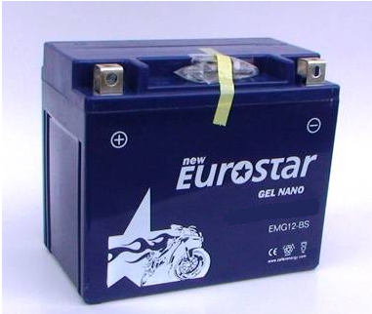
Figure 1: Eurostar Nano Gel Battery [2]

2.1.3 Motor
3 pieces of multifunctional plug and use DC motors are used in this product. One of the motors is used to open or close the parasol, one is to used incline the body according to the incoming angle of the sunlight and the other is used to rotate the body according to the direction of the sunlight.

DC Multifunctional Motor System [3]
Width x Height x Depth: 15.2 cm x 7.6 cm x 6.3 cm
Weight: 3.0 kg
Maximum Torque: 30 Nm
Gearbox ratio: 1:5-1:200

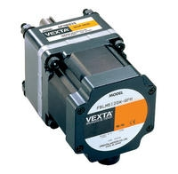
Figure 2: DC Multifunctional Motor System [3]

2.1.4 Camera
In order to provide continuous shade, a camera is used to detect the direction of sunlight by image processing. Since sunlight is the most powerful source of light on the earth, it is sufficient to use a basic webcam to detect the sunlight. On the other hand, it is necessary to protect the camera against the burning effect of the sunlight. An enduring structural box and a filter will be used to protect the camera.

Logitech Webcam C160 [4]
Width x Height x Depth: 7.8 x 21 x 21 mm

Figure 3: Logitech Webcam C160 [4]

2.1.5 Rain Sensor
ModaCar Cyclone 470090 Rain Sensor is used to detect rain.
ModaCar Cyclone 470090 Rain Sensor[5]
Dimensions: 85 x 115 x 30 mm
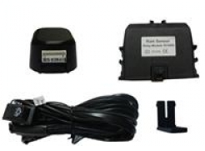
Figure 4: ModaCar Cyclone 470090 Rain Sensor[5]

2.1.6 PC Module
PC/104 Embedded PC Module is used to control the system.

PC/104 Embedded PC Module[6]
Dimensions: 90 x 96mm (3.6" x 3.8")
Height: 15mm (0.6")
Operating temperature range:
0 to 60 ºC (Extended Temperature range versions available)
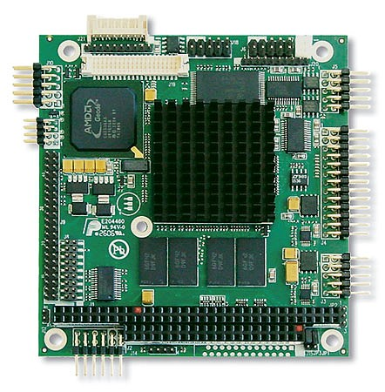
Figure 5: PC/104 Embedded PC Module[6]

2.2 Power Requirements
The main system will use DC current supplied by a rechargeable battery. The operating voltage will be 12 Vdc.

Eurostar Nano Gel Battery [2]
DC Voltage: 12 V
DC Current : 12 A

DC Multifunctional Motor System[3]
Input voltage: 12 V
Output power: 75W or 120W

PC/104 Embedded PC Module [5]
Power supply: Single +5V only
Power consumption: <6W

ModaCar Cyclone 470090 Rain Sensor [6]
Operating Voltage: 10-16 Vdc
Current consumption: 400 mA/1 A
Relay current: 20 A
Perception Sensitivity: 0.005 ml (water)

AD7574: 8-Bit Analog-to-Digital Converter [7]
Low Power Dissipation: 30 mW
Input voltage: 5V-15V
Output Voltage: 0.4 V- 4 V
Low digital input current: 10 microamperes

AD558: 8-bit digital-to-analog converter [8]
Single-Supply Operation: +5 V to +15 V
Input Voltage: 4.5V to 16.5V
Output Voltage: 0 V-2.56V
Low digital input current: 100 microamperes
Low Power: 75 mW

2.3 Standards
Radiation is the emission of a stream of particles or electromagnetic rays in nuclear decay [9]. Radiation causes ionizations in living cells and these ions cause image in human bodies. At low doses, the cells can repair the damage but at high doses the cells cannot repair themselves and change permanently or die. With higher whole body doses (>300 rem), the body's immune system is damaged and become defenceless against diseases. At whole body doses near 400 rem, about 50% of the people die due mostly from infections [10].
In our project, the most critical component in terms of radiation is RS485 transceiver. Other materials are less harmful than RS485. We use DRS4485 Dual
RS485 Transceiver for serial communication. Total radiation dose of RS485 transceiver is about 100 rem [11]. At these low doses humans are not affected the effect of radiation. So our project is not dangerous for people in terms of radiation.
“ISO 14001:2004 specifies requirements for an environmental management system to enable an organization to develop and implement a policy and objectives which take into account legal requirements and other requirements to which the organization subscribes, and information about significant environmental aspects. It applies to those environmental aspects that the organization identifies as those, which it can control, and those that it can influence. It does not itself state specific environmental performance criteria.” [12]
According to this criterion, we should take the environmental issues into consideration by deciding the place that our product will be built in and the cloth that is used on the top of the umbrella. Our product can be built on coasts. Therefore, the construction site should be chosen carefully in order not to hurt natural life. Another issue is the cloth of our product. The overlying cloth is waterproof and may be dangerous to the ecosystem. So, appropriate material should be used.

3. PRELIMINARY DESIGN
3.1 System Block Diagram
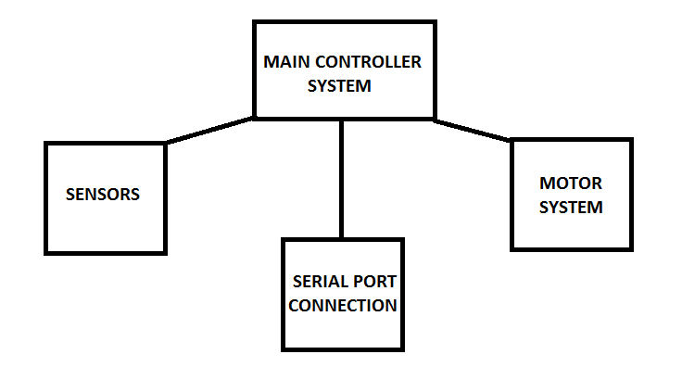
Figure 6: Main Blocks of the System

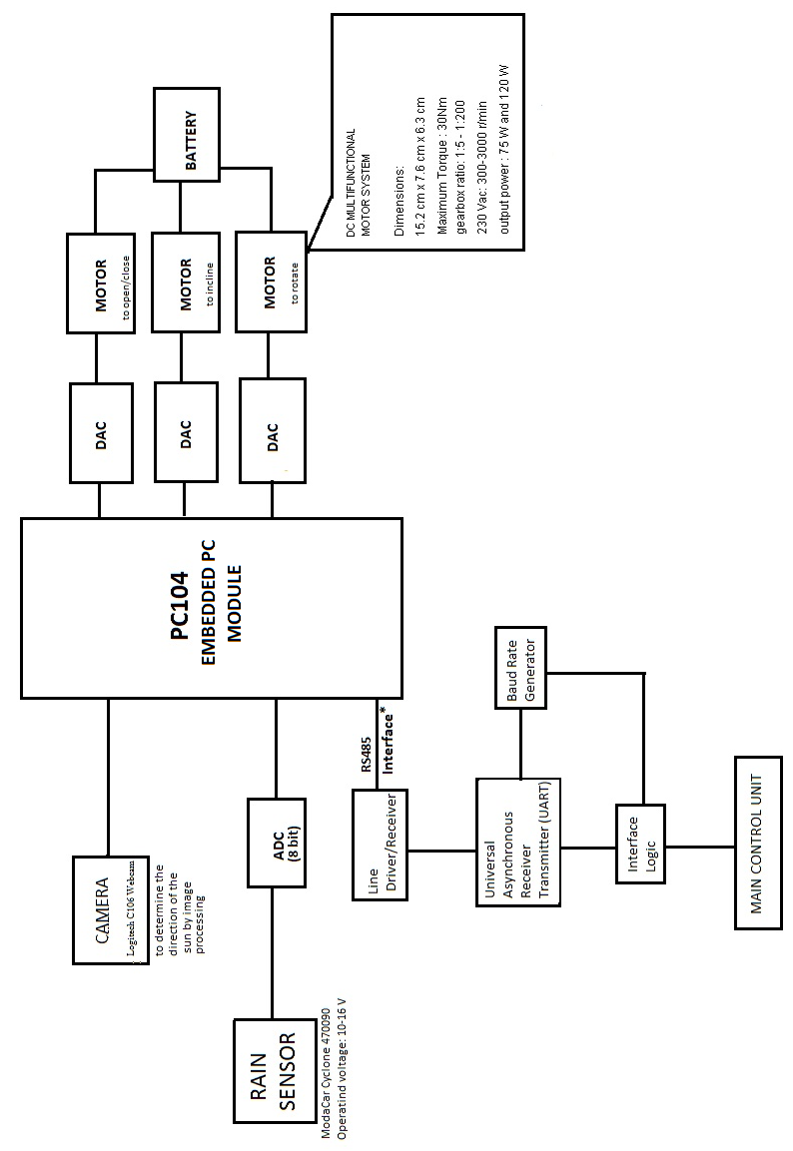
Figure 7: System Block Diagram
As seen from the system block diagram above, the main controller system, which is PC104 embedded PC module, acts as a brain. It arranges the relationships between other blocks.
When the system is turned on from the main control room by using the RS485 serial port connection, the first motor uses the energy to open the parasol. The sensors start making measurements and immediately share it with the PC module. If there is no rain, the camera detects the angle and direction of the incoming sunlight. According to the data provided by the camera, the second motor inclines the parasol body and the third motor rotates it. When the rain sensor senses the rain, the parasol becomes perpendicular to the ground.

3.2 System Operational Flowchart Diagram
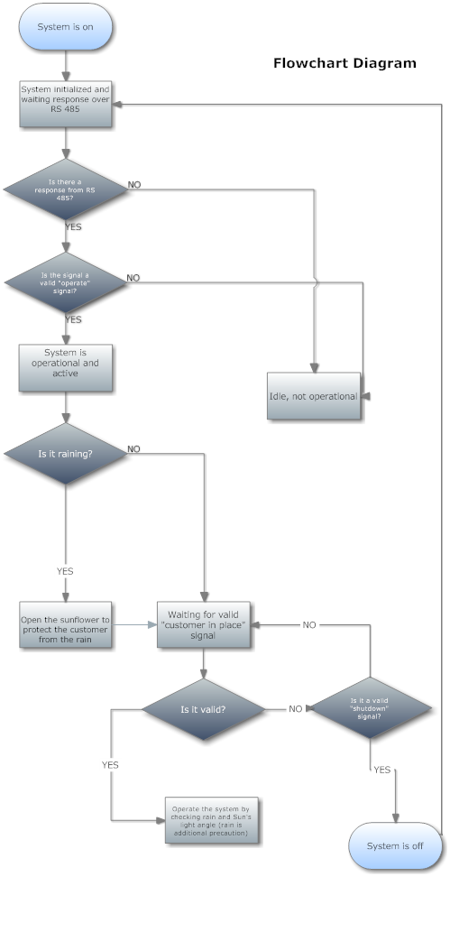
Figure 8: Operation Flowchart Diagram of the System
3.3 Software Structures
The operating system in which we control the mechanism of our product is not limited because it works not only in Windows but also MacOS, Linux etc. Our programming language is Java. So we don’t have any restrictions for the screen format. That implies also that any computer that has JDK environment can control the system.

3.4 User Interfaces
The product can be turned on or off and can be controlled from a computer in the main control room over the RS485 serial port connection. The real users, in this case the customers in hotels, cafes etc., do not have any interaction with the sensors, motors, PC module or serial port. These pieces are hidden in boxes.
Any computer that has RS232 serial port or USB port is capable of controlling the sunflower system because our program can only be used over these connection ports. Our interface can be used on computers that don’t have Serial port on it. Figure 9 shows the USB to RS232 converter.
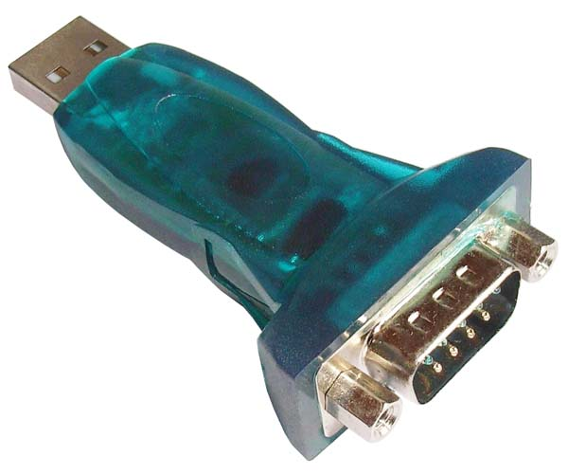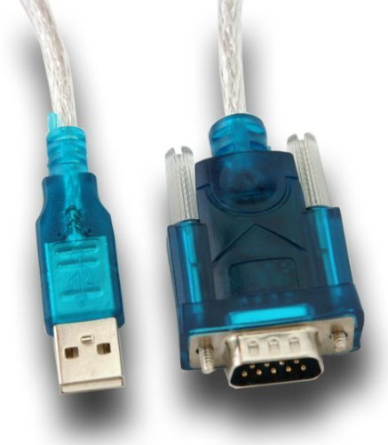

Figure 9: USB to RS232 Converter [13][14]

RS 232 will be converted to RS 485 by a converter (Figure 10) in order to send data over longer distances without losing any data.
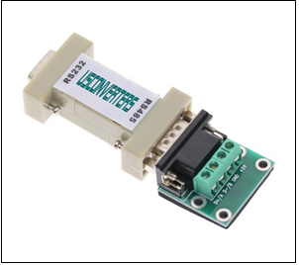

Figure 10: RS232 to RS485 Converter [15]

The main control room interface will be window based, which can be used without any problems on 800*600 or higher resolution capable computers. User selects the port that the system is connected to, and after that a new window is opened. In the new window, the user can use mouse or keyboard to control the system.
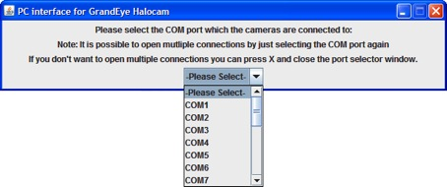
Figure 11: PC Interface Window
The first window looks like the one above. The next window has a keyboard like layout and, some data fields to inform the user about current situation depending on the data that is transferred or received from the system. The data field shows necessary information such as whether the system is active or not.
In general, the real users are not dealing with anything. The user of the computer in the main control room is dealing with a simple and easy-to-use interface.

3.5 Product Tree
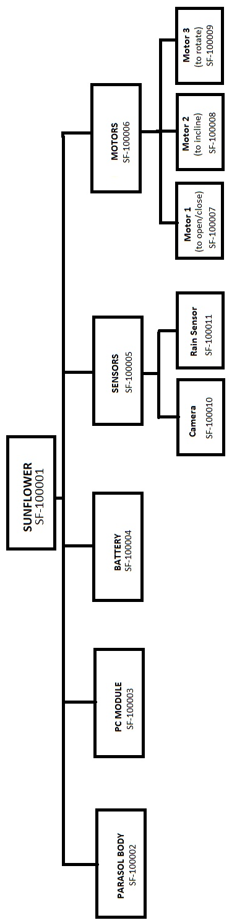
Figure 12: Product Tree
4. REFERENCES

[1] Wind Load Calculator
<” http://www.asyasat.com/calc.aspx?mid=12&mcid=3&pt=Enlem-Boylam%20ve%20uydu%20a%C3%A7%C4%B1s%C4%B1na%20g%C3%B6re%20anten%20a%C3%A7%C4%B1s%C4%B1%20hesaplama=”>

[2] Eurostar Nano Gel Battery
<”http://www.akudunyasi.com/Eurostar-Nano-Gel-Motor-Akusu-12Volt-12Amper-Aku-012V-0012Ah,PR-2608.html=”>

[3] DC Multifunctional Motor System
<”http://www.temsan.org/orientalmotor/id2.htm=”>

[4] Logitech Webcam C160
<”http://channel.logitech.com/storage/DataSheet/48DC532B5A7D5EFDC125775200608173.pdf=”>

[5] ModaCar Cyclone 470090 Rain Sensor
<” http://www.modacar.com.tr/urun/modacar-cyclone-yagmur-sensoru-470090.aspx=”>

[6] PC/104 Embedded PC Module
<” http://www.eurotech-inc.com/single-board-computer-geode-pc104-cpu1233.asp=”>

[7] AD7574: 8-Bit Analog-to-Digital Converter
<”http://www.analog.com/static/imported-files/data_sheets/AD7574.pdf=”>

[8] AD558: AD558: 8-bit digital-to-analog converter
<”http://www.analog.com/static/imported-files/data_sheets/AD558.pdf=”>

[9] Radiation
<”http://www.thefreedictionary.com/radioactivity =”>

[10] Radiation and Risk
<”http://www.physics.isu.edu/radinf/risk.htm=”>

[11] DRS4485 Dual RS485 Interface Transceiver
<”http://www.aeroflex.com/AMS/pagesproduct/datasheets/4485.pdf=”>

[12] ISO 14001:2004
<”http://www.iso.org/iso/iso_catalogue/catalogue_ics/catalogue_detail_ics.htm?csnumber=31807=”>

[13] USB to RS232 Converter
<”http://www.alcamsatcam.com/usb-den-rs232-ye-cevirici-adaptor-kablo-widq151246=”>

[14] USB to RS232 Converter
<” http://image.made-in-china.com/2f0j00mvLaeOHsLIbP/USB-to-RS232-Adapter-ZT-RS232B-.jpg=”>

[15] RS485 Converter
<”http://www.coolgear.com/images/US-485C.jpg=”>

